- Recruitment Module:
- Letter of Intent format need to correct (ML,MP, IE)
- Appointment Letter need to correct (ML,MP, IE)
- Recruitment dashboard
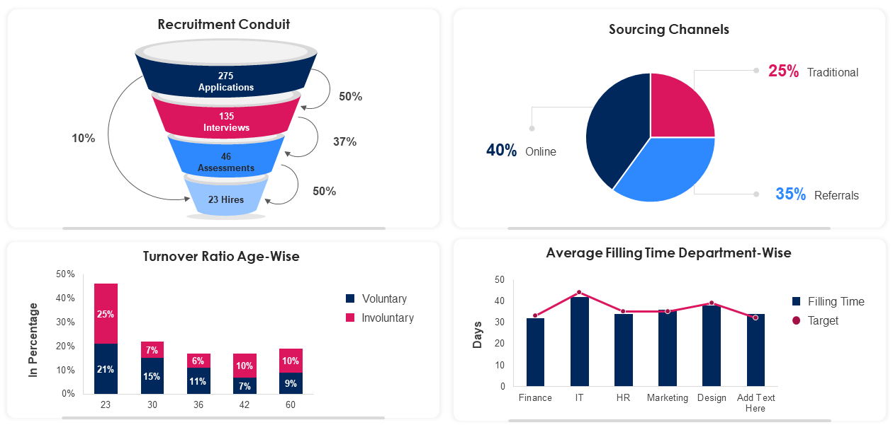

- ESSP Module:
- My profile data representation enhancement. (Hierarchical view, Concern HR, Available leave balance etc.)
- Payslip need to add under my profile.

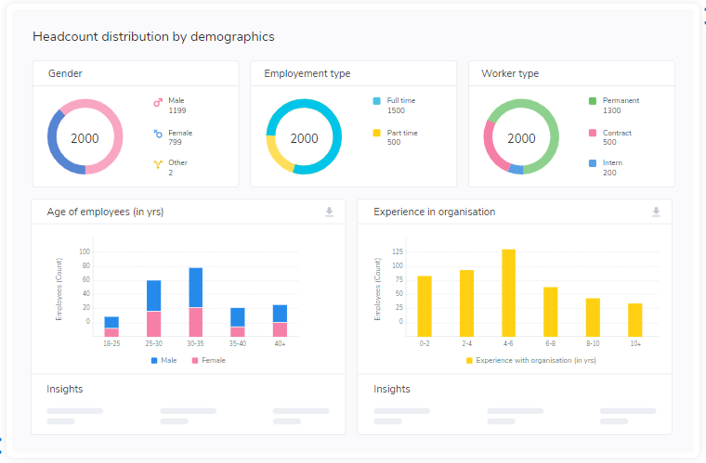
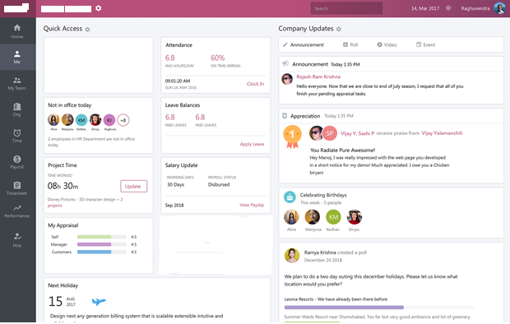

- Payroll Module:
- Need Dashboard.
- Need provision for change loan installment amount, auto complete and after trash loan installment should get revised.
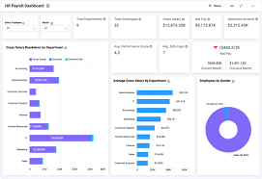
- Asset module :
- Need to make it ready.

- PMS Module:
- Need to connect with survey module. Fetch the appraisal value from Survey Module.

- Leave Module:

2
Month

3
Month

1
Month

Late Dates:

Absent Days:

Leave Balance:

